- HERO SECTION
  - Clone a navy blue background with no hero image. When it is actually red with a pattern of wrenches (see asset manifest).
  - Text is not the correct one. It’s already saying what we do, when in live version we have this: SERVICES
Whether you are remodeling your kitchen or bathroom or you have an emergency water leak, count on J. Blanton Plumbing to help you with all your plumbing needs. CTA: SCHEDULE A SERVICE
  - Text is also misaligned and hiding under the header.
  - It's also missing the secondary nav bar underneath.

CLONE
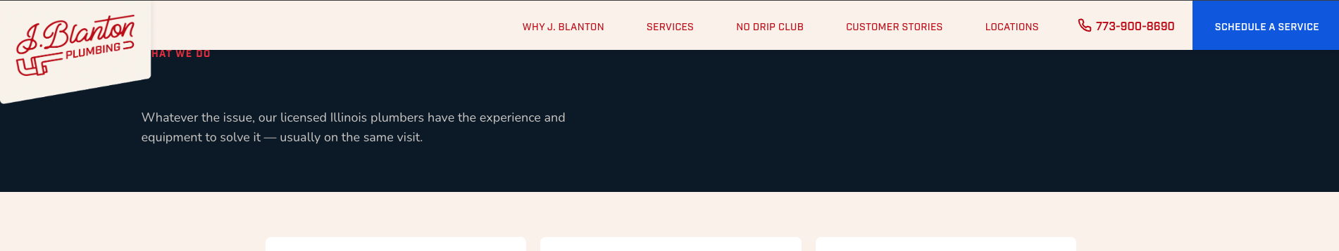

LIVE
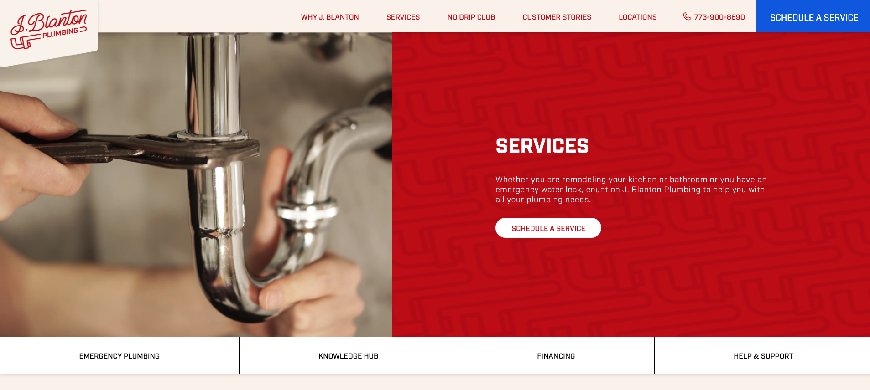

- SERVICES CARD SECTION
  - Text is missing and actually it was pasted in the hero section. It is not where it is supposed to be.
  - SERVICES action title is missing as well.
  - I don’t think cards are the right size as they fit really different and are not aligned in the same way.

CLONE
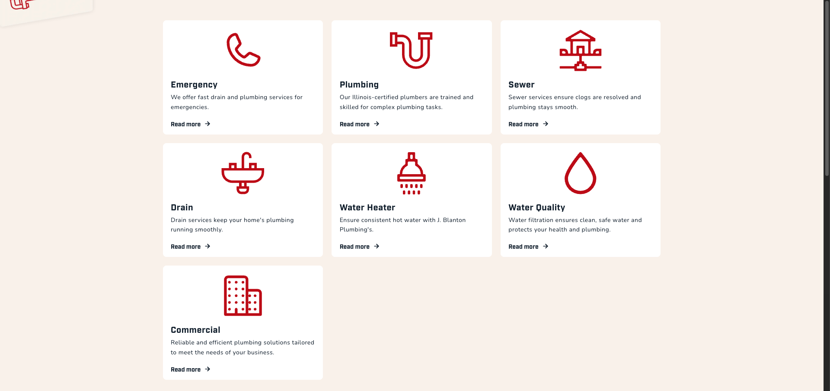

LIVE
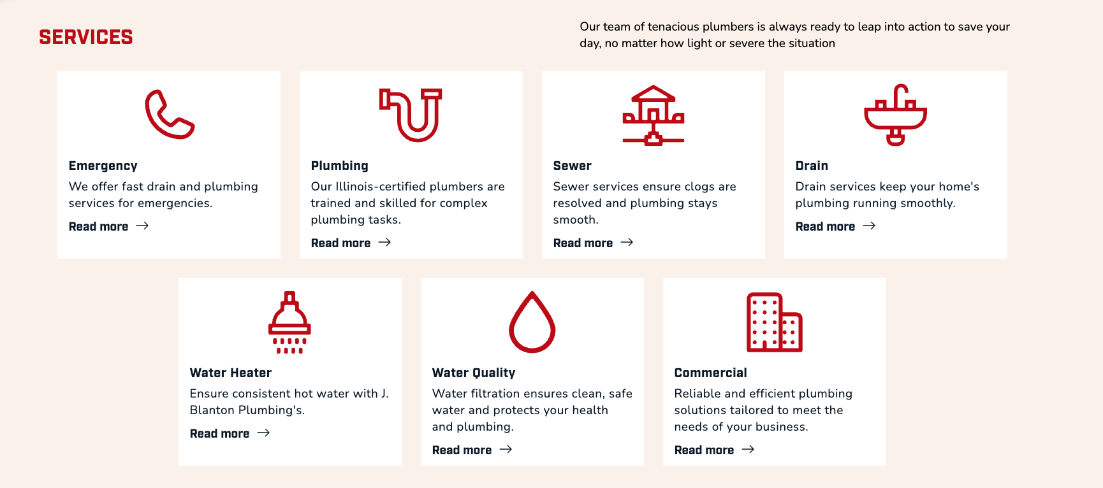

- NO DRIP CLUB SECTION
  - Non existent in clone.
  - This is what the live page shows exactly below the services card section.

LIVE
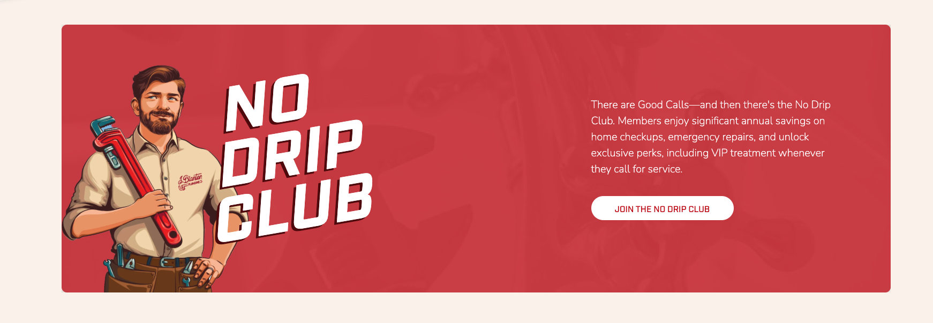

- REASONS TO BELIEVE SECTION
  - Non existent in clone.
  - This is what the live page shows exactly below the no drip club section.
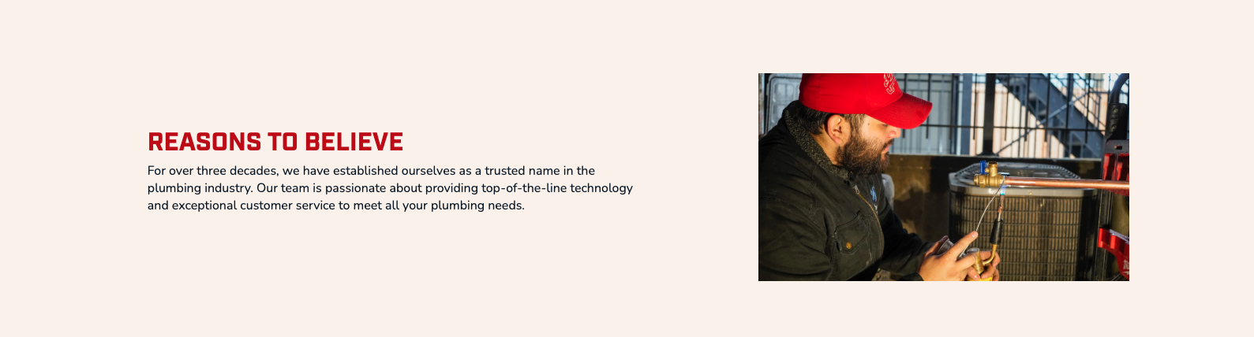

- REVIEWS SECTION ( I know it is a widget but it should at least have a placeholder)
  - Non existent in clone.
  - This is what the live page shows exactly below REASONS TO BELIEVE section.
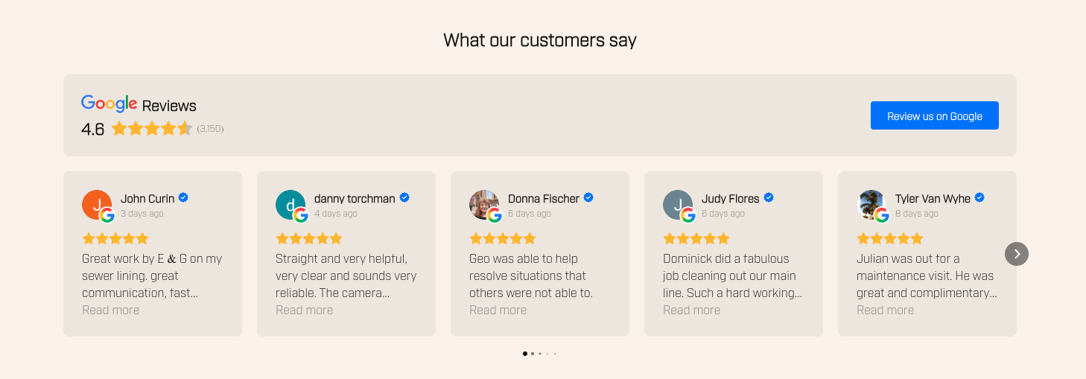

- SOCIAL PROOF SECTION ( I know it is a widget but it should at least have a placeholder)
  - Non existent in clone.
  - This is what the live page shows exactly below REVIEWS section.

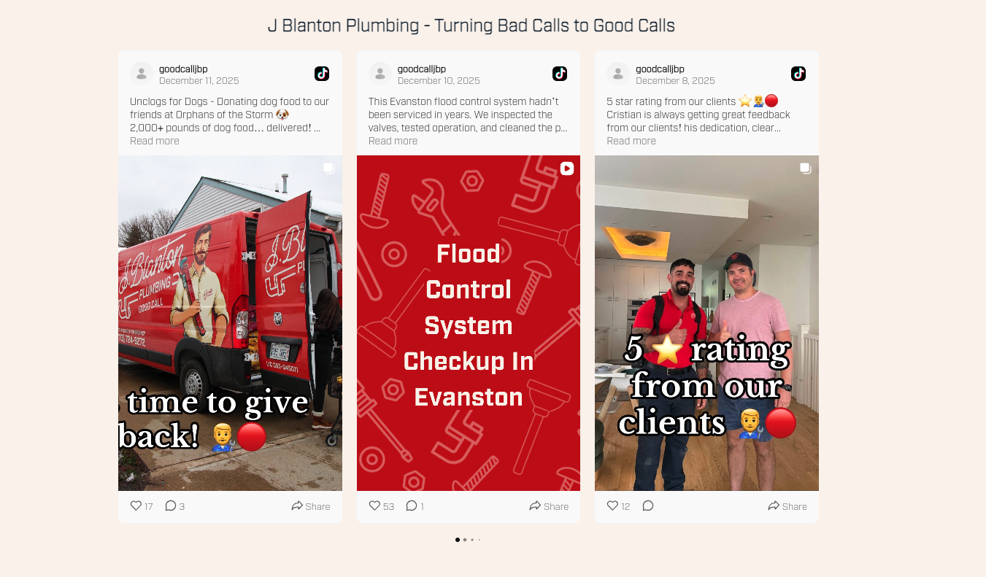

- FINAL CTA SECTION
  - You have added a final CTA that doesnt exist in this template. Live page just goes straight to the footer.

CLONE
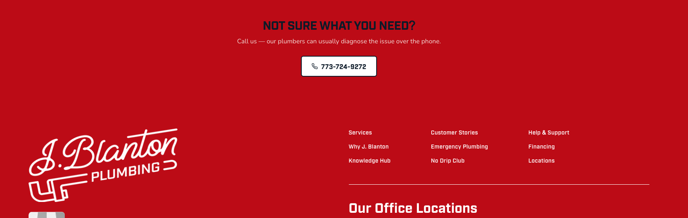

LIVE
